Airlines Project Details

1)

The business process was about monitoring booking processes and measuring customer- satisfaction rate.

We followed the “Inmon” approach by making an ERD first in a Normalized form then we created the dimensional modeling for reporting.

In ERD we have 8 entities (Passenger, Flight, Ticket, Channel, Fare_type, Frequent_Flyer_Class, Customer_Service and Class_Upgrade_Status).

We created a Galaxy Schema in Dimensional modeling which has two facts tables (Customer_Rate_Fact and Booking_Transaction_Fact) and 7 Dimensions (Customer_Services_Dimension, Channel_Dimension,_ Date_Dimension, Passenger_Dimension, Flight_Dimension, Class_Upgrade_Status_Dimension and Frequent_Flyers_Class_Dimension).

The booking transaction and customer rate facts granularity level are up-to-date on a daily basis.

We followed Lnmon’s approach as it is much easier to create dimensional modeling from the data available in the data warehouse because the data is already cleaned and integrated.

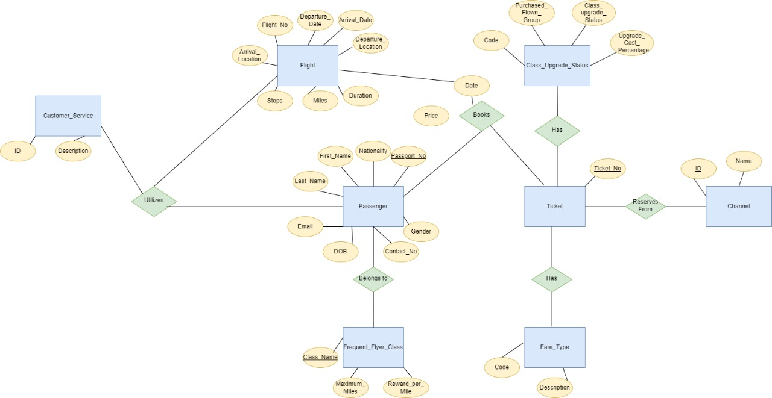2)

3)

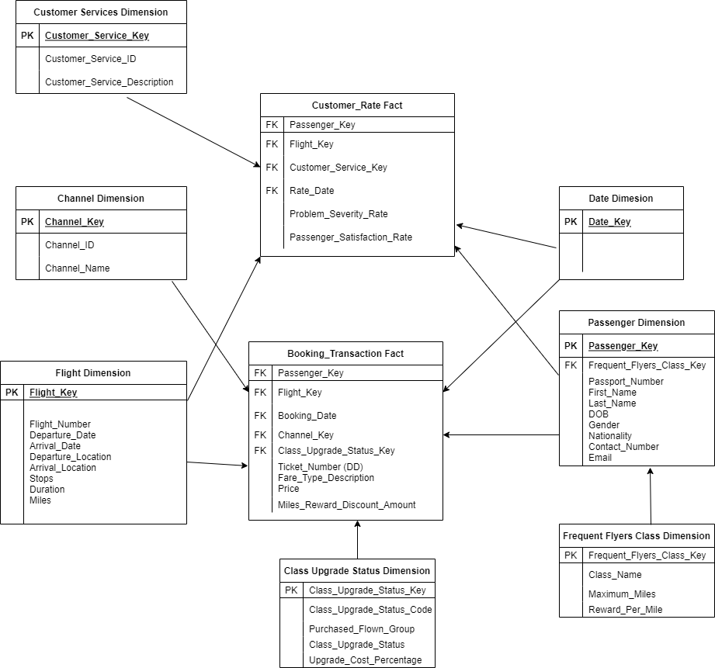

* Passenger_Dimension has all info about each passenger.
* Frequent_Flyers_Class_Dimension has the following info.

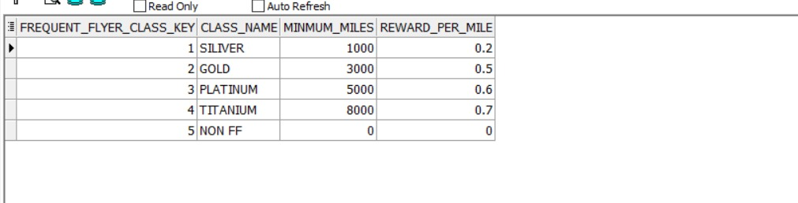

* Class_Upgrade_Status_Dimension has the following info.

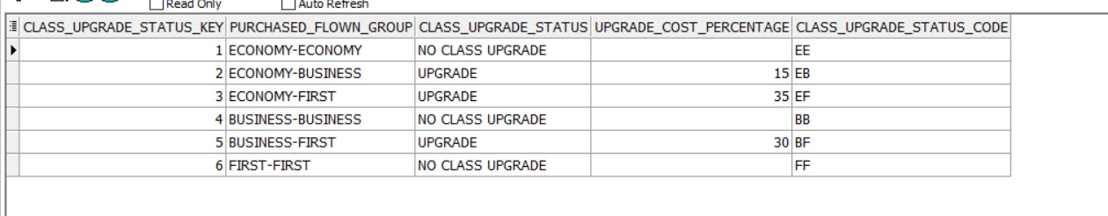

Booking_Transaction_Fact represents each ticket transaction that is booked by each passenger per each flight and what fare does he pay for. The Fare_Type_Description column represents the fare that is booked by each passenger throught its six values (Economy Full Fare, Economy Discounted, Business Full Fare, Business Discounted, First Full Fare, First Discounted). The Price column represent the cost of each fare type.

The Class_Upgrade_Status column shows us whether the passenger has upgrade his ticket or not. The Miles_Reward_Discount_Amount column has the redeem miles amount according to the class of the frequent flyer and the number of miles he has. So to calculate the final price after redeeming miles, you can subtract the Price column from the Miles_Reward_Discount_Amount column.

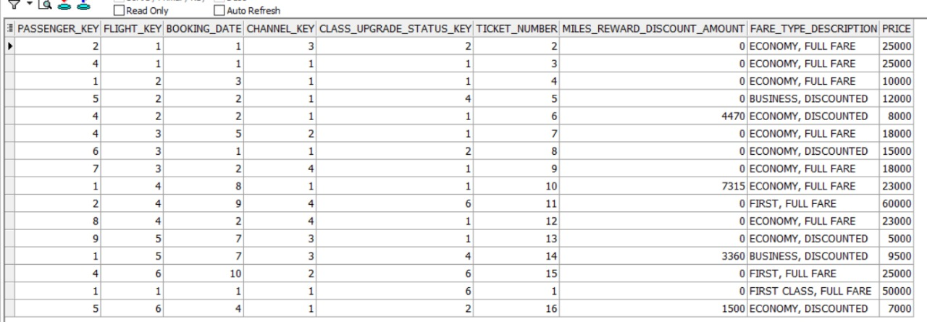

* Customer_Services_Dimension has the type of customer service activities that is monitored by the company to enhance their business process to satisfy their customers.

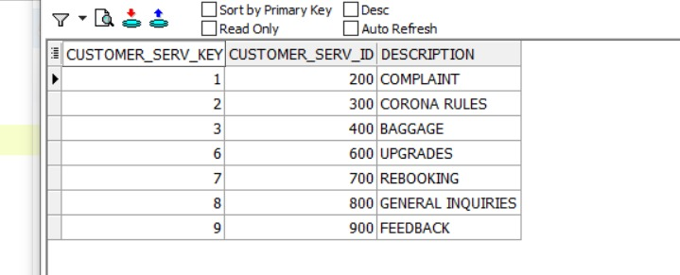

* Channel_Dimension has the type of channel that is used by each passenger during booking.

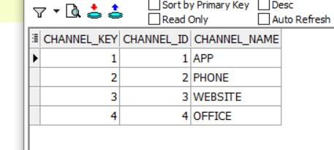

* Flight_Dimension has all info about each flight.
* Customer_Rate_Fact represents the customer service activities done by each passenger and his satisfaction rate.

